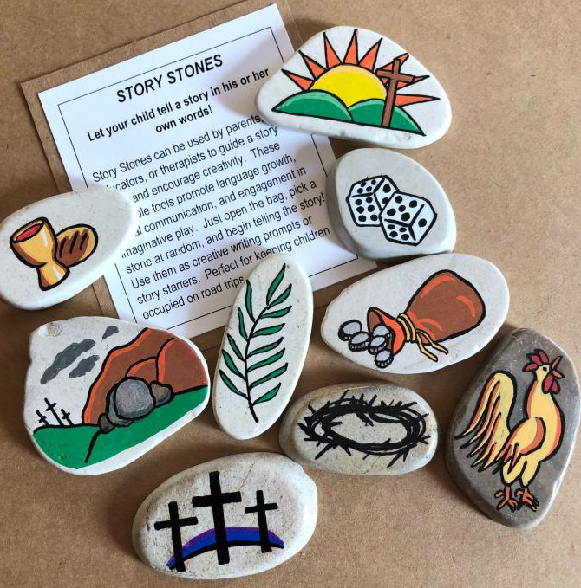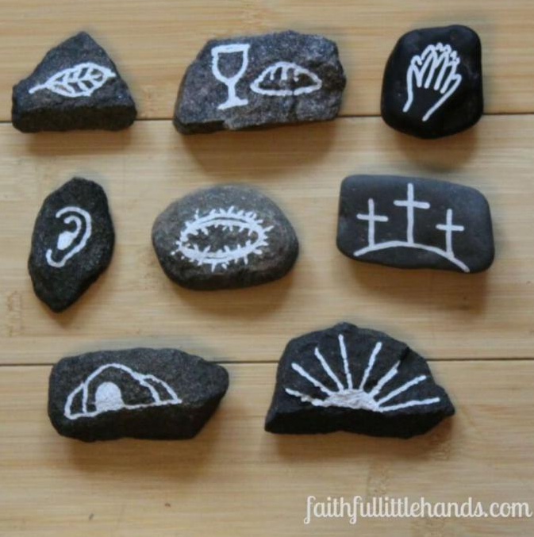

Holy Week Story Stones Activity

- Use this activity as part of your Faith5 time, in the evenings, in the morning or at dinner time.
- Supplies: Use what you have at home: natural or glass stones, wooden blocks, cork, sponges, paper, cardboard or any base you can draw one. Grab permanent markers, acrylic paint, or crayons. Now all you need is you and your family’s collective imagination!
- Using the Story Sheet, read a story each night . Each family member makes a drawing a piece of craft material. If you have ideas for more than one picture, make more than one “stones!”
- If you have an ambitious family, you can read through more than one story and keep drawing.
- Use these stones during Holy Week to tell the story of Jesus’ death and resurrection. Let any individual who wants tell the story of Holy Week use their stones. It’s fun to see what each person remembers and how they relate to the story!
- Simple symbol ideas:
  - Palm Leaf or Cloak
  - Perfume bottle
  - Bread & Cup
  - Praying hands
  - Crowing rooster
  - Three crosses
  - Tomb covered with stone
  - Raised Jesus or Sunrise

Holy Week Story Sheet
Start each session with each family member sharing highs and lows of the day.
End each session by making the sign of the cross on each person’s forehead or hand, saying, “You are a beloved Child of God.”

Palm Sunday
Create: Draw a palm leaf, cloak or other symbol of this story on one or more of your “stones”
Read Jesus’ Triumphal Entry into Jerusalem, Matthew 21:1-11 or Palm Sunday (Spark Story Bible, pg 358)
Talk: Have you ever been to parade? How were the parade honorees treated? What similarities to that experience do you see in Jesus’ entry into Jerusalem? What are the differences?

Monday
Create: Draw a perfume bottle or other symbol of this story on one or more of your “stones”
Read: The Anointing at Bethany, Matthew 26:6-13 or Banquet with Simon (Spark Story Bible, pg 294)
Talk: Tell about a time when you received an expensive gift. How did that make you feel? Alternately, tell about a time you gave an expensive gift and why you did that.

Tuesday
Create: Draw the bread & cup or other symbol of this story on one or more of your “stones”
Read part of The Passover with the Disciples, Matthew 26:17-19 and The Institution of the Lord’s Supper, Matthew 26:26-30 or The Last Supper (Spark Story Bible, pg 364)
Talk: Talk about the elements of worship that you see in the story of Jesus celebrating Passover with the disciples.

Wednesday
Create: Draw a praying hands or other symbol of this story on one or more of your “stones”
Read: Jesus Prays in Gethsemane, Matthew 26:36-46 and part of The Betrayal and Arrest of Jesus, Matthew 26: 47-50 or Jesus is Betrayed (Spark Story Bible, pg 370)
Talk: Tell of a time when you were sad and wanted support from family. Imagine that they fell asleep or were distracted instead of helping you. How would that make you feel? Tell how you can be a helpful supporter to your family.

Thursday
Create: Draw a crowing rooster or other symbol of this story on one or more of your “stones”
Read part of Jesus Before the High Priest, Matthew 26:57-58 and Peter’s Denial of Jesus, Matthew 26:69-75 or Jesus is Betrayed (Spark Story Bible, pg 370)
Talk: Tell of a time when a friend didn’t act like a friend to you. How did that make you feel?
Tell how you feel when others pressure you to ignore or be mean to your friends.

Friday
Create: Draw a three crosses or other symbol of this story on one or more of your “stones”
Read Jesus Brought Before Pilate, Matthew 27:1-2 and part of Pilate Questions Jesus, Matthew 27:11-12 and part of Barabbas or Jesus?, Matthew 27:20-23 and The Soldiers Mock Jesus, Matthew 27:27-31
or The Day Jesus Died (Spark Story Bible, pg 376)
Talk: Tell about a time when you were sad. What color or sound or picture comes in your mind when you think of that sad time. What made you feel better?

Saturday
Create: Draw a tomb sealed with a rock or other symbol of this story on one or more of your “stones”
Read: part of The Death of Jesus, Matthew 27:45-51 and The Burial of Jesus, Matthew 27:57-61 and The Guard at the Tomb, Matthew 27:62-66 or The Day Jesus Died(Spark Story Bible, pg 376)
Talk: Tell about a funeral or memorial service that you attended. What do you remember about that experience?

Easter Sunday
Create: Draw an alive Jesus, sunrise or other symbol of this story on one or more of your “stones”
Read: The Resurrection of Jesus, Matthew 28:1-10 or The Empty Tomb (Spark Story Bible, pg 382)
Talk: Describe a color, sound or picture in your mind when you think about Jesus being resurrected. How will you celebrate Easter?

*Spark Story Bible is available in hard copy and digital version at www.wearesparkhouse.org, Kindle Store, Amazon.com

